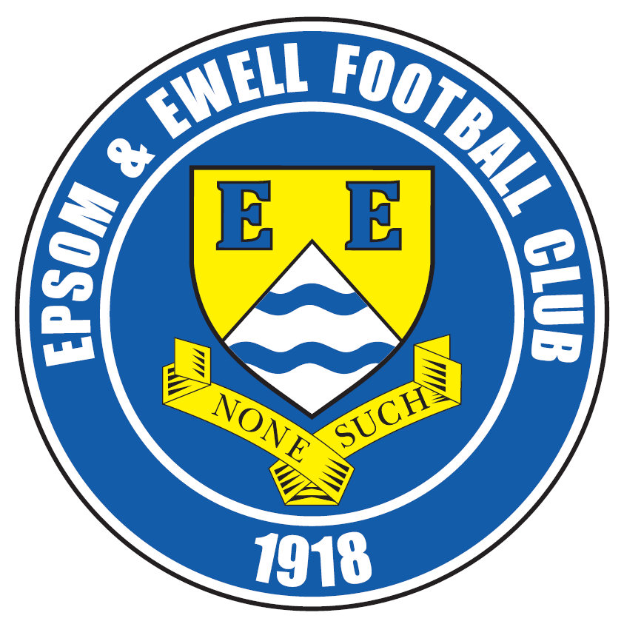 | Epsom & Ewell F.C.  6  v  Colliers Wood United  Tuesday, 8th September 2015
Good evening and welcome to High Road for our latest League match with Colliers Wood United. We welcome their players and officials, today’s match officials and our regular supporters.

Our opponents have started well this season and as usual will present a tough challenge. I wrote that line in our previous home match against Raynes Park Vale and the two sides do have many similarities. They are not often favoured to do well in this league, but continue to punch above their perceived weight to most outsiders. However, both are very established sides at this level now and it should not be forgotten that the bulk of this side reached the last 32 of the F.A. Vase last season so we would be well advised to bring our ‘A’ game today.

Both sides won the home fixture in the League last season; Wood defeated us 3-2 with a very late winner on the August Bank Holiday Saturday, despite two goals from Ali Dewar, while two goals from Kyle Hough enabled us to defeat them 2-1 in the March return match.

The last time we were here was for the aforementioned League match against Raynes Park Vale. In terrible conditions and with Daryl Cooper-Smith filling in between the posts we restricted them to very little in the way of chances and won 3-1. Two days before that we gained a useful point at Westfield from a 0-0 draw, despite the loss of Matt Ferdinando after 55 minutes for a second yellow card. The less said about the refereeing in that match the better!

Just two days ago we travelled to play Horsham in the F.A. Vase, where frankly we never really got going and crashed 3-0 to an admittedly very competent team. We have had some rotten luck in the Cups with matches against arguably the best sides in Kent and Sussex that we could have drawn at that stage and of course we have pulled out the Ryman South leaders Dorking Wanderers in the Surrey Senior Cup too, so someone up there didn’t like us this season!

Following today’s match, we travel to Spelthorne Sports on Saturday; arguably the scene of our best performance last season when we handed them their first home defeat in 18 months with a 3-0 win. We then return here for a League match at home to AFC Hayes, who we have met before, under the guise of Brook House

Finally, just in case you were wondering why we have a black and white picture on the cover, it is 90 years ago this week (Saturday 5th September) since we played our first ever match at West Street; our ground for the next 68 years. They commemorated this achievement later that season with a full picture of team and officials and I thought it was appropriate to share it today.

For the record, we drew 2-2 with Kingstonian that day and yes, it rained then too!

Enjoy the game!

Rich

Check us out on Facebook www.facebook.com/epsomandewellfc or on Twitter @EEFCOfficial

Cover photos by 1) unknown 2) Gemma Jarman

- Our club line up 90 years ago at our new ground in West Street

- Kyle Hough scores the winner against Colliers Wood United back in April


Cherry Red Records
Combined Counties League
Premier Division Table 2015/16
Inc Saturday 5th September | P | W | D | L | F | A | Pts | GD | H | A
Ashford Town (Mx) | 6 | 6 | 0 | 0 | 15 | 4 | 18 | +11 | 30/4 | 24/10
Hartley Wintney | 5 | 5 | 0 | 0 | 27 | 5 | 15 | +22 | 30/1 | 10/10
Hanworth Villa | 5 | 5 | 0 | 0 | 14 | 1 | 15 | +13 | 21/11 | 23/4
Camberley Town | 6 | 4 | 1 | 1 | 11 | 7 | 13 | +4 | 16/4 | 20/2
Epsom & Ewell | 5 | 3 | 2 | 0 | 8 | 4 | 11 | +4 | X | X
Colliers Wood United | 5 | 3 | 1 | 1 | 13 | 8 | 10 | +5 | 8/9 | 28/11
Horley Town | 4 | 3 | 0 | 1 | 9 | 3 | 9 | +6 | 27/2 | 28/12
Raynes Park Vale | 5 | 3 | 0 | 2 | 11 | 8 | 9 | +3 | 3-1 | 28/3
Knaphill | 5 | 3 | 0 | 2 | 9 | 6 | 9 | +3 | 12/3 | 14/11
Westfield | 5 | 2 | 2 | 1 | 5 | 5 | 8 | 0 | 26/3 | 0-0
Windsor | 5 | 2 | 2 | 1 | 9 | 10 | 8 | -1 | 2-2 | 23/1
Farnham Town | 4 | 2 | 1 | 1 | 9 | 3 | 7 | +6 | 26/9 | 6/2
Chessington & Hook | 4 | 2 | 1 | 1 | 6 | 4 | 7 | +2 | 7/11 | 19/3
Guildford City | 6 | 2 | 1 | 3 | 6 | 13 | 7 | -7 | 5/12 | 2/4
Bedfont Sports | 4 | 1 | 2 | 1 | 6 | 4 | 5 | +2 | 13/2 | 31/10
AFC Hayes | 3 | 1 | 0 | 2 | 2 | 3 | 3 | -1 | 19/9 | 9/1
Chertsey Town | 5 | 0 | 1 | 4 | 2 | 10 | 1 | -8 | 17/10 | 5/3
Sutton Common Rovers | 6 | 0 | 1 | 5 | 9 | 19 | 1 | -10 | 19/12 | 2-1
Spelthorne Sports | 6 | 0 | 1 | 5 | 3 | 13 | 1 | -10 | 16/1 | 12/9
Redhill | 5 | 0 | 0 | 5 | 2 | 13 | 0 | -11 | 2/1 | 1-0
Badshot Lea | 5 | 0 | 0 | 5 | 6 | 18 | 0 | -12 | 9/4 | 12/12
Cove | 6 | 0 | 0 | 6 | 3 | 24 | 0 | -21 | 8/12 | 3/10

Lucky Day? – 8th September
Played 16 - Won 6 Drawn 3 Lost 7 - F 21 A 34 - PPG 1.31 - Average
Our Club record against Colliers Wood United
Played 19 - Won 12 Drawn 2 Lost 5 - For 39 Against 27 PPG 2.00 - Very Good
Largest wins and losses against our opponent
8th March 2014 - Won 4-0 - League ---- 21st February 2007 - Lost 0-3 - League
Last visit
Saturday 4th April 2015 - Won 2-1 - Combined Counties League

First Eleven Appearances - (max 7 – including Horsham match – 06/09/15)
Name | Debut | 2014/15 |  |  |  | Career Totals
Name | Debut | App | Sub | Total | Goals | App | Sub | Total | Goals
AJAYI Tayo | 22/08/2015 | 0 | 1 | 1 | 0 | 0 | 1 | 1 | 0
COOPER-SMITH Daryl | 03/01/2015 | 5 | 2 | 7 | 1 | 14 | 5 | 19 | 7
CURRIE Sam | 04/08/2012 | 7 | 0 | 7 | 0 | 115 | 9 | 124 | 2
DAVISON Conor | 22/08/2015 | 0 | 1 | 1 | 0 | 0 | 1 | 1 | 0
DEAN Dan | 02/08/2014 | 7 | 0 | 7 | 0 | 43 | 1 | 44 | 0
DEWAR Ali | 29/10/2011 | 0 | 0 | 0 | 0 | 55 | 35 | 90 | 10
EACOTT Michael | 02/08/2014 | 6 | 0 | 6 | 0 | 52 | 0 | 52 | 0
FARRELL Matt | 02/08/2014 | 6 | 0 | 6 | 1 | 47 | 3 | 50 | 8
FERDINANDO Matt | 20/09/2014 | 4 | 0 | 4 | 0 | 31 | 4 | 35 | 6
GRIFFIN Reisse | 08/08/2015 | 5 | 0 | 5 | 0 | 5 | 0 | 5 | 0
HASTINGS Craig | 08/08/2015 | 2 | 3 | 5 | 0 | 2 | 3 | 5 | 0
HENDRY Rob | 08/08/2015 | 7 | 0 | 7 | 1 | 7 | 0 | 7 | 1
HOUGH Kyle | 14/08/2007 | 7 | 0 | 7 | 4 | 303 | 15 | 318 | 175
KURDZIEL Jakub | 29/08/2015 | 1 | 0 | 1 | 0 | 1 | 0 | 1 | 0
MARVELL Dale | 15/01/2000 | 6 | 0 | 6 | 0 | 267 | 45 | 312 | 85
MCGREGOR Alex | 08/08/2009 | 0 | 2 | 2 | 0 | 172 | 58 | 230 | 27
MCKAY Alex | 20/12/2008 | 0 | 1 | 1 | 0 | 85 | 27 | 112 | 8
NORTH Rhys | 16/08/2015 | 1 | 2 | 3 | 0 | 1 | 2 | 3 | 0
OLIVER Beckett | 29/08/2015 | 1 | 1 | 2 | 0 | 1 | 1 | 2 | 0
PANAYIOTOU Savvas | 03/01/2015 | 2 | 0 | 2 | 0 | 18 | 3 | 21 | 3
SMITH Matt | 08/08/2009 | 0 | 0 | 0 | 0 | 91 | 43 | 134 | 10
TANTON Matt | 02/08/2014 | 5 | 0 | 5 | 0 | 23 | 4 | 27 | 1
TAYLOR James | 26/08/2013 | 5 | 0 | 5 | 0 | 61 | 8 | 69 | 3

Latest Results and Fixtures
F.A. Cup Preliminary Round – Saturday 29th August
Ashford Town (Mx) | 1-0 | AFC Kempston Rovers
Badshot Lea | 2-4 | Fleet Town
Bedfont & Feltham | 1-1 | AFC Hayes
Bedfont Sports | 1-2 | Hanwell Town
Chertsey Town | 1-4 | Kidlington
Cogenhoe United | 3-0 | Spelthorne Sports
Cove | 0-7 | North Leigh
Farnham Town | 4-2 | Highworth Town
Hartley Wintney | 5-2 | Banbury United
Hythe Town | 0-2 | Chessington & Hook United
Shoreham | 1-1 | Horley Town
Thatcham Town | 3-2 | Guildford City
Combined Counties League – Saturday 29th August
Colliers Wood United | 4-1 | Redhill
Westfield | 0-0 | Epsom & Ewell
Combined Counties League – Monday 31st August
Ashford Town (Mx) | 2-1 | Chertsey Town
Epsom & Ewell | 3-1 | Raynes Park Vale
Hanworth Villa | 2-0 | Spelthorne Sports
Sutton Common Rovers | 2-3 | Guildford City
F.A. Cup Preliminary Round Replays – Tuesday 1st September
AFC Hayes | 1-3 | Bedfont & Feltham
Horley Town | 2-3 | Shoreham
F.A. Vase First Qualifying Round – Saturday 5th September
Ash United | 0-2 | Windsor
Chertsey Town | 5-1 | Tuffley Rovers
Corinthian | 4-1 | Chessington & Hook United
Hanworth Villa | 1-0+ | Desborough Town
Hartley Wintney | 3-2 | Longlevens
Langford | 0-3 | Bedfont Sports
Long Buckby | 3-1 | Spelthorne Sports
Newhaven | 1-0 | Guildford City
Raynes Park Vale | 2-4 | Croydon
Sevenoaks Town | 5-0 | Horley Town
Combined Counties League Cup 1st Round – Saturday 5th September
Redhill | 5-2 | Sandhurst Town
Westfield | 3-1 | Farleigh Rovers
Combined Counties League – Saturday 5th September
Ashford Town (Mx) | 4-0 | Badshot Lea
Camberley Town | 1-1 | Colliers Wood United
Farnham Town | 4-0 | Cove
Knaphill | 4-1 | Sutton Common Rovers
Latest Results and Fixtures
F.A. Vase First Qualifying Round – Sunday 6th September
Horsham | 3-0 | Epsom & Ewell
Combined Counties League – Tuesday 8th September
Chessington & Hook United | V | Hanworth Villa
Epsom & Ewell | V | Colliers Wood United
Farnham Town | V | Badshot Lea
Knaphill | V | Windsor
Emirates F.A. Cup First Qualifying Round – Saturday 12th September
Chessington & Hook United | V | North Leigh
Hartley Wintney | V | Fleet Town
Hoddesdon Town | V | Ashford Town (Mx)
Tooting & Mitcham United | V | Farnham Town
Combined Counties League – Saturday 12th September
AFC Hayes | V | Colliers Wood United
Badshot Lea | V | Sutton Common Rovers
Cove | V | Knaphill
Guildford City | V | Redhill
Horley Town | V | Raynes Park Vale
Spelthorne Sports | V | Epsom & Ewell
Westfield | V | Camberley Town
Windsor | V | Chertsey Town
Combined Counties League Cup 1st Round – Monday 14th September
Sutton Common Rovers | V | Guildford City
Combined Counties League Cup 1st Round – Tuesday 15th September
Bedfont Sports | V | Abbey Rangers
Horley Town | V | Staines Lammas
Windsor | V | Colliers Wood United
Combined Counties League – Tuesday 15th September
Ashford Town (Mx) | V | Farnham Town
Chertsey Town | V | AFC Hayes
Chessington & Hook United | V | Redhill
Combined Counties League – Saturday 19th September
Ashford Town (Mx) | V | Hanworth Villa
Camberley Town | V | Bedfont Sports
Chertsey Town | V | Spelthorne Sports
Cove | V | Guildford City
Epsom & Ewell | V | AFC Hayes
Farnham Town | V | Horley Town
Hartley Wintney | V | Chessington & Hook United
Knaphill | V | Colliers Wood United
Raynes Park Vale | V | Badshot Lea
Redhill | V | Windsor
Sutton Common Rovers | V | Westfield

From behind the goal
Westfield 0-0 Epsom & Ewell
Combined Counties League - Saturday 29th August 2015

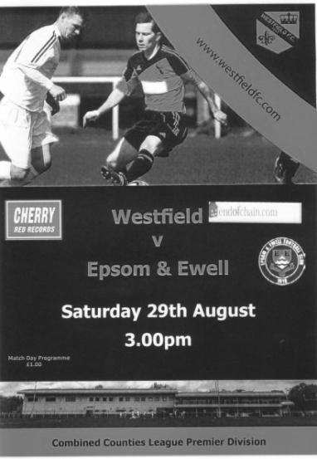
Salts battle injustice to claim a point

Bearing in mind our record at the refurbished Woking Park with two heavy defeats prior to this visit, a point should be seen as a good result. When you throw in the circumstances of the match you could argue with some justification that the first goalless draw under Glyn Mandeville's charge was actually an excellent result.

We made one change from Saturday's win at Sutton Common Rovers with Jakub Kurdziel making his debut at left back for the unavailable Matt Tanton and back on a natural grass surface that was perfect for play after a light shower at the start of the match that continued throughout, both teams started off with good intentions of playing some football. Unfortunately the first half contained little in the way of goal mouth action as the elevens were so evenly matched and committed that they cancelled each other out entirely!

Kyle Hough fired an early chance over the bar from outside the penalty area after Rob Hendry had headed a long Michael Eacott free kick into his path and Matt Farrell volleyed just wide of the far post after Dan Dean had flicked on a Sam Currie header. Apart from these early opportunities the home side shaded possession in the first half but Michael Eacott wasn't required to do anything at all as Dan Dean and Matt Farrell protected our back four excellently all day. Kurdziel had a couple of nervy moments to start with but grew in confidence and did well when a left wing Westfield cross eluded both Eacott and Dale Marvell and our "new boy" was alert to block a strike on goal at the far post just before the half time whistle.

Matt Ferdinando was extremely unfortunate after 37 minutes when his sliding tackle was considered worthy of a yellow card, despite not actually making contact with anyone, but the referee seemed dead set on allowing anything of note to develop, making no use whatsoever of the advantage rule that is actually there to help him, and generally stifling the few opportunities that actually occurred.

The second half started well for us as we started to press a little more. Ferdinando received the ball from a great touch pass by Hough but his run ended with a shot that went well wide. We then had a scare at the other end when a Westfield near post corner was flicked goalwards but Sam Currie was at the far post to clear the danger. It was the first shot on target and it was at this point that you realised that our Captain

had now made one more save at this point than both keepers combined!

But the game was about to take an unsavoury turn as Ferdinando received a second yellow card for a slightly late challenge in the 56th minute. It was hard to see the incident from where I was, but others nearby said that it probably was worth a yellow card. This of course made the harsh decision on his earlier card more of an issue.

A subsequent free kick for the foul looped up towards goal and was cleared by Eacott with the ball close to the crossbar and we struggled to get back into the game for a few minutes as the opposition tried to take advantage of the extra man. Without a doubt the game opened up a bit at this stage, but we replaced the injured Reisse Griffin with Daryl Cooper-Smith, while on the other flank Craig Hastings came on for the injured Jakub Kurdziel and we reshuffled the back line substantially. As a result the last half hour remained very even as we gave as good as we got.

We did have one concern after 73 minutes when Matt Jackson was put through but never really got the ball under control and Eacott was out quickly to smother the danger, picking up a knock in the process that earned the Westfield striker a yellow card.

Because of a lack of confidence in the officiating, notably a yellow card for Farrell for just bumping into a player, followed by a yellow card for the Westfield substitute Andy Wright, who had been on the field for all of twenty five seconds and culminating in a laughably poor decision on a corner kick that was not awarded, the game began to deteriorate. Then Farrell was poleaxed on the edge of the area and we had another talking point.

Despite the wall being just six yards away as was clear from the lines that mark the penalty area, Dale Marvell got his low free kick on target and in the 76th minute Stuart Norman had to make the first actual save of the match, although he was only able to parry the ball and Kyle Hough knocked in the rebound from close range only to then see the Assistant's flag raised for offside somewhat belatedly. People standing across the field and in a better position than me said they believed Hough was onside when the free kick was taken and although we didn't complain about the decision at the time, it really wouldn't have surprised me if this had been the case!

Hastings came forward to meet a deep Marvell corner but his effort was blocked by a defender and as we went further into injury time another Marvell set piece was met at the far post by Cooper-Smith, but the ball had taken a slight deflection on the way and our man was only able to find the side netting with his strike.

But in truth this was a very even game and a goal for us would have been harsh on our hosts in a game of few real chances that will be remembered for a number of bizarre decisions and a flurry of cards from an uncommunicative referee that found himself a bit out of his depth.

Team: Michael Eacott, Sam Currie ©, Jakub Kurdziel, James Taylor, Dale Marvell, Dan Dean, Matt Ferdinando, Matt Farrell, Kyle Hough, Rob Hendry, Reisse Griffin

Subs: Daryl Cooper-Smith for Griffin (65), Craig Hastings for Kurdziel (70), Beckett Oliver for Hendry (87)

From behind the goal
Epsom & Ewell 3-1 Raynes Park Vale
Combined Counties League - Premier Division - Monday 31st August 2015

Cooper-Smith the stand-in star as Salts take points from Vale

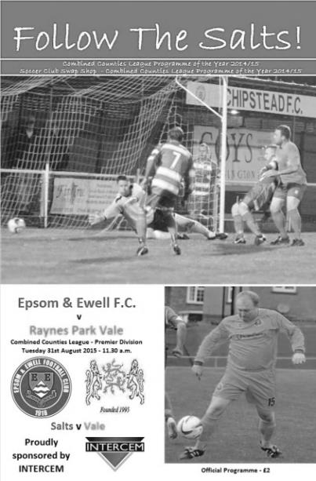
Cast your mind back exactly 12 months to a torrential Bank Holiday Monday match with Horley and if you were at High Road for that match you would need no further description of the conditions today as our Great British summer continued! Not that it makes any difference to the High Road pitch which just loves water and its growing reputation for handling whatever downpours there might be attracted a healthy attendance of 62 for a morning match.

The big story going into this game was the non-appearance of our expected keeper, signed on to cover for the working Michael Eacott. However, our Manager had a plan and Daryl Cooper-Smith filled the big man's shoes, if not his kit, making him the first person to appear in public wearing the baggy green since the Australians were beaten in the Ashes!

The other two changes from Saturday's draw at Westfield were injury related as Jakub Kurdziel and Reisse Griffin were replaced by the returning Matt Tanton and Beckett Oliver, who started for the first time and produced a fine performance. To pick just Oliver out though would be harsh as a number of fine individual performances were on show in this match, not least from the referee, who showed how it is possible to referee competently in difficult conditions.

In fact, to a man we were very good today and by the end we were full value for the win. The back four protected Cooper-Smith really well, although he also looked very competent and showed good handling on a really difficult day for any keeper. Our midfield were terriers but with a little more of a cutting edge with Oliver on the left and Matt Ferdinando on the right breaking through from time to time. And of course, up front Kyle Hough did what he does, scoring another two goals with good support from the hard working Rob Hendry.

In the first ten minutes we threatened with a dangerous Dale Marvell free kick that skidded across the six yard area and although Dan Dean retrieved it and won a corner it was headed clear. Still we pressed and a great through ball found Hough who tried to round the keeper but he got a hand to it and the danger was cleared.

One area of weakness against Westfield was our lack of a dangerous delivery, but on a skiddy wet day it was vital that we got the ball into the danger area as often as possible, as you never know what might happen. This theory was proven beyond doubt in the 26th minute. Oliver was giving his full back a lot of trouble and he sent a dangerous ball in from the left wing towards Ferdinando. Under pressure from our right winger, Anthony Moulds made an ill-advised decision

to chest the ball back to his keeper but got the contact wrong and the ball ended up in the net beyond the keeper's despairing dive.

Hendry tried his luck with a well struck shot a few minutes later but the keeper got everything behind it although we extended our lead in the 41st minute. Ferdinando will admit that his corner was probably the worst one he took all day, but the low delivery deflected up off a defender to the far post where James Taylor retrieved the ball and a quick pass to Hough enabled him to take a touch and curl the ball into the top corner. It was right in the corner and if the goal frame had been designed in a different way we might have seen one of those Trevor Brooking moments (kids- look it up on YouTube or ask your dad!).

Oliver saw his well struck shot deflected for a corner while Matt Farrell sliced his shot wide after getting into a good position so the half time whistle came as a relief to the visitors. However, the second half was a little more even for a while and we had a scare after 57 minutes when Cooper-Smith and Taylor had a miscommunication on the edge of the area that nearly ended up costing us but they repaired the damage between them and the danger was cleared.

We started to sit back a little but it wasn't a concern and we still looked the more dangerous. Hendry took a pass in midfield and in the same move he left his man for dead as he turned for goal and let fly from twenty yards but the keeper tipped it wide at full stretch and in the 75th minute we made it 3-0 when Hough collected the ball outside the area and beat at least three challenges before burying the ball across the keeper and into the bottom corner of the net. It was his 175th goal for the club and at this rate we will be marking his 200 well before the season is out.

At this point we saw some substitutions. Alex McKay made his first appearance of the season in relief of the bandaged Dan Dean and almost scoring within moments of coming on as his header from a corner was blocked on the line by Moulds, while Rhys North came on as Farrell had a well-deserved ten minutes off. Shortly after this, Craig Hastings gave our "veteran" defender Marvell a breather. With Sam Currie now alongside McKay in the midfield roles and North at right back we took a moment or two to settle and Cooper-Smith was forced into his first real save after 82 minutes as he held a low shot well.

Unfortunately for him, his day wouldn't end with the clean sheet that we deserved as an 85th minute corner was headed in at the near post by Jerome Smart and the visitors started to push on in the belief that they could maybe get something out of this game, but all this really did was leave gaps for us to exploit and we nearly made them pay on more than one occasion. Hendry nearly intercepted a poor back pass that the keeper had no option but to smother, conceding a rare free kick for the offence but Hendry's shot that came from the set piece about six yards out was deflected for a corner.

A Ferdinando corner then bounced off the top of the bar before McKay was first to another fine delivery but didn't get enough on it and the ball flashed wide of the far post. The next delivery would I'm sure seen him bury the header but Currie got there in front of him, although he couldn't keep the ball down.

As the whistle blew for full time we were able to celebrate only our second home win against Raynes Park in the last eight visits and the result took us up to fourth place in the table. Without a doubt this was our best performance of the season and yet no one would have been expecting it as before the game everyone was more concerned about our missing keeper. Funny old game!

Team: Daryl Cooper-Smith, Sam Currie ©, Matt Tanton, James Taylor, Dale Marvell, Dan Dean, Beckett Oliver, Matt Farrell, Kyle Hough, Rob Hendry, Matt Ferdinando

Subs: Alex McKay for Dean (76), Rhys North for Farrell (81), Craig Hastings for Marvell (83)

Horsham report to follow in AFC Hayes programme….

Club Records - 8th September
Date | Day | Competition |  | Opponents |  | Scorers
08/09/28 | Sat | London League | A | Millwall United | 1-1 | J.Parr
08/09/34 | Sat | London League | H | Grays Athletic | 1-0 | M.Wiggins
08/09/45 | Sat | F.A. Cup Preliminary Round | H | Woking | 1-8 | G.Francis
08/09/51 | Sat | Corinthian Memorial Shield 1 | H | Edgware Town | 3-1 | T.Wright (3)
08/09/56 | Sat | F.A. Cup Preliminary Round | H | Bexleyheath & Welling | 1-3 | D.Hermitage
08/09/62 | Sat | F.A. Cup 1q | H | Slough Town | 1-3 | B.Lambert
08/09/65 | Wed | Athenian League 2 | A | Croydon Amateurs | 0-3
08/09/79 | Sat | F.A. Trophy  Preliminary Round | A | Crawley Town | 2-0 | T.Tuite (2, 1 pen)
08/09/84 | Sat | Isthmian League  Premier Division | H | Walthamstow Avenue | 2-2 | T.Tuite, S.Hill
08/09/90 | Sat | Isthmian League 2s | H | Horsham | 1-3 | T.Tweedy
08/09/92 | Tue | Isthmian League Cup Preliminary Round | A | Thame United | 0-3
08/09/93 | Wed | Isthmian League Cup Preliminary Round | H | Hungerford Town | 1-0 | P.Meredith
08/09/98 | Tue | Isthmian League 3 | H | Flackwell Heath | 4-2 | J.Tome (4)
08/09/01 | Sat | Isthmian League 3 | A | Abingdon Town | 2-0 | S.Hatton (2)
08/09/07 | Sat | Combined Counties  Premier Division | A | Egham Town | 1-1 | R.Burns
08/09/12 | Sat | F.A. Cup 1q | A | Bognor Regis Town | 0-4
Historical Decades
90 years ago – Epsom Town F.C.
05/09/25 | Sat | Friendly | H | Kingstonian | 2-2 | R.Marlow, J.Parr
80 years ago – Epsom F.C.
07/09/35 | Sat | London League | A | Leavesden | 2-4 | H.Pullen, C.George (pen)
70 years ago – Epsom F.C.
08/09/45 | Sat | F.A. Cup Preliminary Round | H | Woking | 1-8 | G.Francis
60 years ago – Epsom F.C.
03/09/55 | Sat | Corinthian Memorial Shield 1 | H | Maidenhead United | 0-1
50 years ago – Epsom & Ewell F.C.
08/09/65 | Wed | Athenian League 2 | A | Croydon Amateurs | 0-3
40 years ago – Epsom & Ewell F.C.
06/09/75 | Sat | Athenian League Cup 1 | A | Grays Athletic | 2-1 | T.Tuite (2)
30 years ago – Epsom & Ewell F.C.
07/09/85 | Sat | F.A. Cup 1q | A | Hastings Town | 1-2 | A.Stewart
20 years ago – Epsom & Ewell F.C.
09/09/95 | Sat | Isthmian League 3 | H | Harlow Town | 2-2 | G.Morris (pen), A.Boxall
10 years ago – Epsom & Ewell F.C.
07/09/05 | Wed | Isthmian League Cup 1 | H | Hastings United | 0-3

History Corner – 8th September
90 years ago this week we played our very first match at West Street!!

After a few seasons at Alexandra Recreation Ground and a few more at the Horton Hospital Sports Ground we were finally able to move into a private ground in Ewell Village and celebrated by inviting Kingstonian over for a Friendly challenge match on Saturday 5th September 1925.

We took the lead through our great striker Reg Marlow, although the more experienced side fought back to lead 2-1 by half time. We weren’t finished though and Jack Parr was able to score an equaliser on a very wet day. The West Street era had begun! A full report is on our website.

70 years ago today our club opened for business again after a six year break for World War Two, and our very first opponents were Isthmian League side Woking in the F.A. Cup. It couldn’t have been much tougher!

Containing many new faces we were beaten 8-1 but there was a bright spot on the horizon in the debut of a young lad by the name of Ernest John Watkins, and Ernie would go on to make over 400 appearances for our club, playing for fifteen years and then giving seven further years of service to Banstead Athletic before retiring in 1968 at the age of 47! Who knows how long he could have played for and how good he could have been if he had trained frequently, as it was not his favourite part of the job and the coach often had to pick him up from the Rifleman pub!

64 years ago today Tommy Wright scored a hat trick for us as we defeated Edgware Town 3-1 in the Corinthian League Memorial Shield, which was the equivalent of their League Cup. What we didn’t realise at the time is that we would go all the way to the Final that season, losing out narrowly 2-1 to League Champions Hounslow after leading for an hour in front of 5,000 at the Saffrons; home of Eastbourne F.C. who are these days known as Eastbourne Town.

36 years ago today Tommy Tuite scored twice as we won 2-0 at Town Mead, the old home of Southern League Crawley Town in the F.A. Trophy. How times have changed down there!

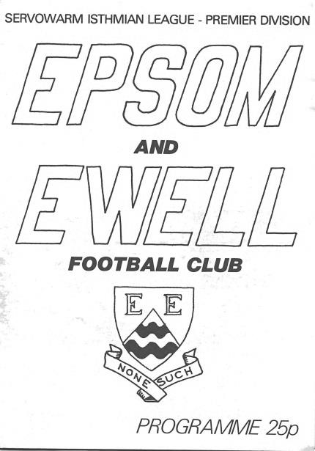
31 years ago today Tommy Tuite and Steve Hill both scored, but the elusive first League win of the season wouldn’t come just yet as we drew 2-2 at home to Walthamstow Avenue in our opening season as members of the Isthmian League Premier Division. (see programme pictured)

30 years ago this week we travelled to Elphinstone Road, home of Hastings Town for an F.A. Cup tie. It was their first season at the lower ground, having moved in from the higher ground when United had folded that summer, but they beat us 2-1 despite a goal from Andy Stewart. Within a few years the Town changed their name to United and exactly twenty years to the day later they defeated us in what was to be our final Isthmian League Cup match, 3-0 at Merland Rise.

17 years ago today we conceded early but four goals from Portugese striker Joao Tome enabled us to turn the game around and a late goal for Flackwell Heath was of no significance. This was our fourth win to open the League season but still we weren’t top as Wingate & Finchley had a point more from an extra game, and we would have to wait four more years to witness an Epsom team at the top of a League table; making a gap of 22 years since we’d last been there!

Centre page for results

Centre page for results




Every Opponent A-Z
Over the years we have played many, many different opponents. Exactly how many is a difficult question, as it all depends on your definition. Are Camberley & Yorktown different to Camberley Town, or are Epsom Town different to Epsom F.C. or Epsom & Ewell F.C.?

In my analysis I have classed them as the same team, and will work through them all from A to Z. Some we have played many times, whilst others we have met just once or twice. Enjoy!


Post Office Engineers / Telecoms: Played 24 - W18 D1 L5 - F70 A31 - PPG - 2.26 - Fantastic

If you travel from Epsom to Croydon there are two main ways to get there by road. One is along the A232 and the other is through Stafford Road up to the Five Ways junction. About a mile before you reach Croydon there is an unassuming road that links the two; Plough Lane in Wallington.

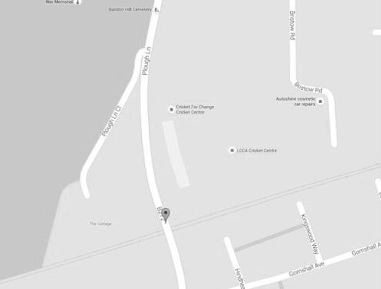
Plough Lane with the Plough Pub further North (out of picture)
and Stafford Road to the South (also out of picture)

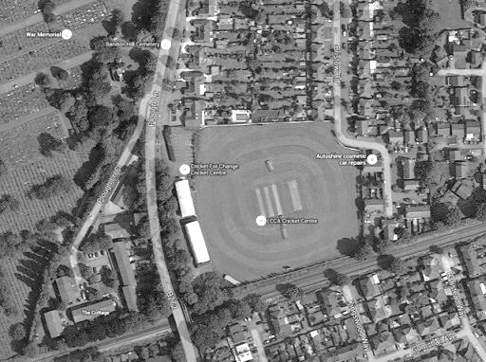
What people don’t realise these days is that this site, now the home of a Cricket Centre, used to be home to a number of Wallington clubs, but most famously, the Post Office Engineers, who were a London League club between the wars and for a while afterwards.

We of course were also members back then, and we first met for a Friendly challenge match on 27th August 1932 at West Street, winning 5-1. Within a month they were back again; this time in the London League Cup which had recently been inaugurated and included both divisions of the League as the Engineers were in the lower division that year. The result was identical except that this time Billy Williams scored a hat trick, when in the first match he had only scored twice!

The Engineers came up to the Premier Division for 1933/34, having finished third, four places above our Reserves, and our opening match of the season, exactly 52 weeks after our first meeting, ended with a similar story as we won 4-1. Our first visit to Plough Lane came on 6th January 1934 where a hat trick from Leslie Marlow and two goals from Tommy Dunne secured an easy 5-0 win.

It would be easy at this point to draw the conclusion that the opposition weren’t very strong, but it must be pointed out that they had only just moved up into Senior football and as a Works side, had plenty of people they could call on who were of a good standard. Additionally, we were very good back then.

The following season 1934/35 would contain our first defeat against them; 0-2 on the opening day of the season, again at West Street, and again exactly 52 weeks after the previous home fixture. Those fixture planners were imaginative!

Despite their win that day, we still claimed the honours as we won the return League match 2-0 at Plough Lane and a League Cup replay there by three goals to one following a 2-2 draw at West Street in the first tie.

We lost both League games in 1935/36 as the Engineers had their best ever season and we had our worst. In fact it was the only season they would finish above us in the League and their 3-0 win at West Street in May 1936 secured a third place finish. Had they won 4-0 they would have finished as Champions, it was that close!

We rebounded in 1936/37 with three wins; two in the League and an Amateur Cup tie that ended 5-2 in our favour but only after extra time. The next season both teams won their home match and we again won all three meetings in 1938/39; the additional match being a London League Cup tie held over from 1937/38 and won by four clear goals as we again opened the season with a visit from the Engineers.

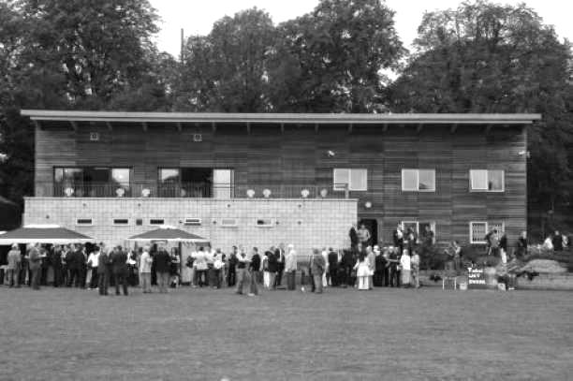
Following the war, they took a season out before re-joining in 1946/47 and midway through the season changed their name; first to London Telecoms and then starting the following season as Post Office Telecoms. However, all was not well as they lost their stand in a fire in 1946 and with two consecutive finishes at the foot of the table they were relegated, with some of their players and their Press Secretary, A.W. “Ned” Kelly joining us for 1948/49 as a result.

The club rebuilt the stand eventually and we played a final friendly match at West Street on Easter Saturday 12the April 1952, winning 4-1 before they dropped into Intermediate football, playing in the Nemean League amongst others before folding at some point in the sixties or seventies.

That’s not quite the end of the story though as the ground lay vacant for many years and used to be easily visible on the train line from Wallington to Waddon, but in the early nineties the replacement stand was knocked down and the site developed into a cricket centre (see new structure which is built on the site of the old stand). It’s nice to know that the ground didn’t end up beneath housing like so many other venues, although there is little remaining to remind anyone of its glory days when teams like Epsom, Carshalton Athletic, Dagenham, Romford, Finchley, Park Royal, Tooting & Mitcham, Grays Athletic, Tilbury and Chelmsford visited as equals.

Colliers Wood United – History
The club, one of the oldest in the country, and which has now been in existence for 141 years, received a well-deserved recognition award from the FA for 125 years of playing football during 2011.

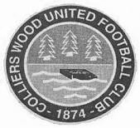
Colliers Wood United FC was founded way back in 1874 and the early years of their existence were spent in the Wimbledon and Sutton leagues before moving on to the Surrey Intermediate League (Southern Division). During the late sixties and early seventies, the club were members of the Surrey Senior League for a short time, playing in the newly formed division one where they won the league title in 1969/70.

Over the years, “The Wood” has reached a number of Surrey FA Cup Finals. In 1988/89 they lost 1-2 to Bradbank Sports in the Intermediate Cup Final and in 1991/92 they beat Woking & Horsell 4-0 in the final of the same competition.

The local recreation ground prevented the progress of the club due to the limited facilities and a search for a new ground was launched. Adequate facilities were found at Wibbandune Sports Ground in 1991 and the ground has steadily improved since then.

2001/02 saw the club enter the Surrey County Senior League where they finished a creditable 5th. The following season, they finished as runners up.

In 2002/03, the league amalgamated with the Combined Counties League and the club were founder members of the new Division 1 where they finished as runners up and were promoted to the Premier Division.

They have continued to improve. In 2004/05, they finished 14th of the 24 clubs. The following season, they finished fourth and had a fine FA Vase run, beating Chichester City United, Raynes Park Vale and Greenwich Borough, before losing to VCD Athletic in the 2nd round proper.

In 2006/07 they entered the FA Cup for the first time, defeating Chipstead after a replay before succumbing to Worthing 0-3.

After a brief ground share at Croydon FC, the club moved back to Wibbandune where ground improvements included the addition of excellent floodlighting, a new covered terrace and a 120 seat stand.

In March 2012, the club added a new away team changing room, new spectator ground lavatories and re-laid the entire playing surface including drainage thanks to a £71,000 grant from the Football Association. They also reached the 2011/12 final of the League Cup at Farnborough FC on 4th May v Guernsey FC in front of 667 spectators, which they lost 0-2 after extra time, becoming the first club to keep a 90 minute clean sheet against The Islanders.

Following a second renovation of the pitch in April, the club returned to Wibbandune in July 2013 and the under 18 youth section was re-started.

In 2014/15, Wood have reached the FA Vase 4th round (last 32 nationally) and the Surrey Senior Cup quarter finals for the first time in their history. They reached the final of the League Cup again in 2014/15, but once more lost in extra time, this time 1-2 to Camberley Town in front of 385 spectators at Woking FC.

Match and Ball Sponsorships – 2015/16
Opponent | Date | Match Sponsor | Ball Sponsor
Hoddesdon Town | 18/07/15 | Geoff Dyke
Windsor | 08/08/15 | Club President Stella Lamont
Erith & Belvedere | 16/08/15 | Mike Lovett
Raynes Park Vale | 31/08/15 | EEFC Management Committee
Colliers Wood United | 08/09/15 | Bookham Building Supplies
AFC Hayes | 19/09/15
Farnham Town | 26/09/15
Chertsey Town | 17/10/15
Dorking Wanderers (SSC) | 20/10/15
Chessington & Hook United | 07/11/15
Hanworth Villa | 21/11/15
Guildford City | 05/12/15
Cove | 08/12/15
Sutton Common Rovers | 19/12/15
Redhill | 02/01/16
Spelthorne Sports | 16/01/16
Hartley Wintney | 30/01/16
Bedfont Sports | 13/02/16
Horley Town | 27/02/16
Knaphill | 12/03/16
Westfield | 26/03/16
Badshot Lea | 09/04/16
Camberley Town | 16/04/16
Ashford Town (Mx) | 30/04/16
For League, League Cup and Surrey Senior Cup Matches:
Match sponsorship - £40.00 Match ball sponsorship - £25.00. Combined £55.00.
For F.A. Cup and F.A. Vase matches:
Match sponsorship - £50.00 Match ball sponsorship - £30.00. Combined £65.00.

Sponsorship includes: (x2 for match, x3 for match and ball)

Admission, programmes, hospitality and advertising and mascot for the day (if required).
If you are interested, just speak to a Committee Member, or drop me an email at: richard.c.lambert@gmail.com


We also thank our Kit Sponsors INTERCEM

Player Sponsorship
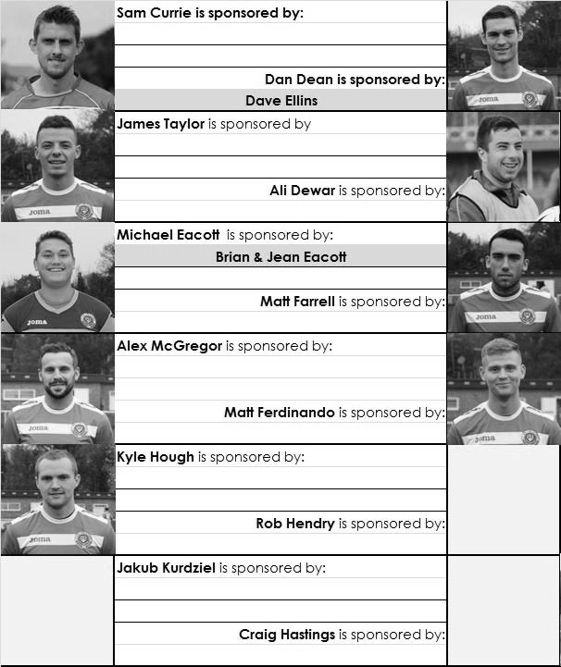

Here is the current list for the 2015/16 season showing all of our players and Management that are currently available for sponsorship this season. Pictures for our new players will feature shortly.

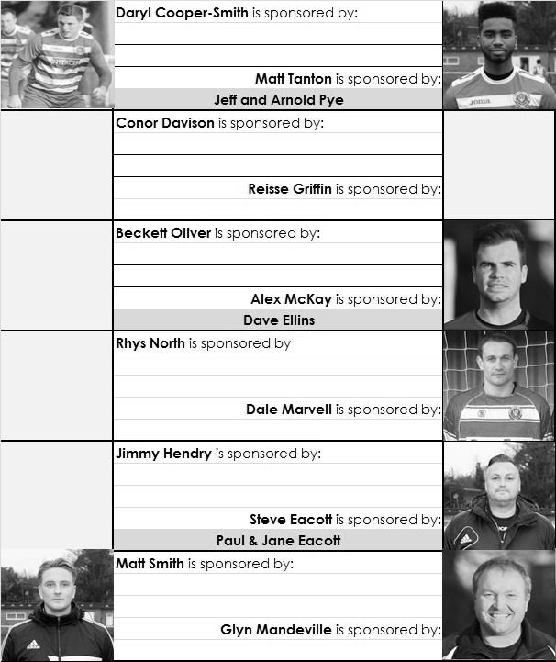
Sponsorship costs just £40 and it is easy to do. Just select a player who has not been previously sponsored and let a Committee Member know that you would like to sponsor them. Beware though. Until we have received the money it is possible for someone to jump in front of you, so don’t delay, sponsor today!

Player Profile – Number 3 – Dale Marvell
Dale Marvell is the next player to complete his profile for us.

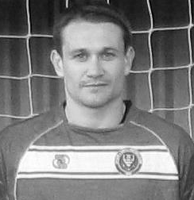
He joined us for the first time in 1999/2000, making his debut in a 2-1 League win over Flackwell Heath at Merland Rise on 15th January 2000. Since then he has been with a number of clubs but has had NINE separate spells with our club over the years, which is a club record.

Age: 35

Position: Anywhere!

Club supported: Chelsea

Favourite Food: Italian

Favourite Film: Gladiator

Messi or Ronaldo: Ronaldo

Favourite Drink: San Miguel

Favourite ground played at: Stamford Bridge

Best moment for the club to date: Winning the League Cup in 2013

Describe the Gaffa in three words: Sexy – Little – Sausage

Dale’s Playing Stats: Debut 15/01/2000
Total Appearances: 311 – Total Goals: 85
Win Ratio (the amount of games he has played in that we have won): 45.42%

Congratulations Matt!
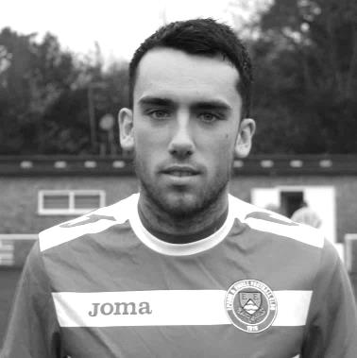
Congratulations go to our midfielder Matt Farrell who made his 50th appearance for the club in our Vase match at Horsham on Sunday 6th September.

He scored on his debut for us in our 2-0 win at Farnham Town on the opening day of last season and has been a regular since, missing very few games last year.

He becomes the 258th player to reach this mark, which might sound a lot, but we have had over 1,500 players over 91 years of senior existence, so it is still quite an achievement! Having said that, he is our second player to reach this mark this season already with others not far away.

Salts Super Six Predictor
The Salts Super Six Predictor Competition is live again today and the tickets are on sale at today’s game to the left of the gate. We have taken a dip into the Conference National today and all of these matches are to be played this afternoon.

The competition is easy to play! To win, you simply need to predict the results of six matches correctly from the three options, fill in the form and make sure it is back with our sellers before the deadline on the ticket.

If you are a club regular, you just need to place your name on the sheet, although if you aren’t, then we’ll need a contact number from you too. We will announce any winners on the website within three working days, so don’t worry we won’t miss you!

We had a big jackpot winner last year and who knows how much could be won this time! It is already up to £151 and you’ll always know the size of the pot before you enter.

Please note that if there is more than one winner, the prize pot would be shared between the winners. All you need to do now is have a go, as many times as you like!

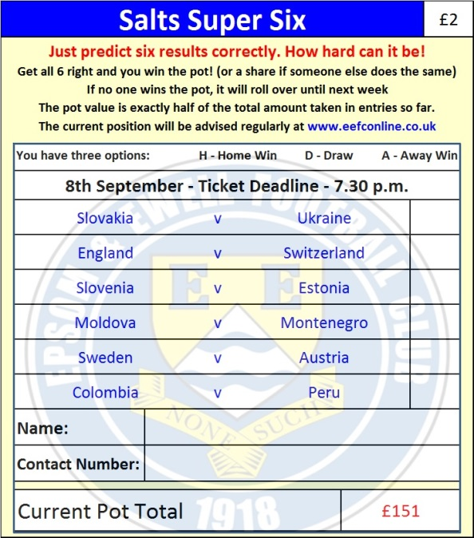

Good luck!

Combined Counties League – Premier Division
Tuesday, 8th September 2015 - Kick-off 7.45 p.m.
Epsom and Ewell  (Royal Blue & White hoops) | V |  | Colliers Wood United  (Red and White / Red / Red)
Squad | NUMBERS
Michael Eacott |  |  | Wester Young
© Sam Currie |  |  | Dan Hughes
Matt Tanton |  |  | Tim Williams
Dale Marvell |  |  | Will Boye ©
James Taylor |  |  | Owen Davies
Dan Dean |  |  | Phil Frodsham
Matt Farrell |  |  | Joe Mead
Matt Ferdinando |  |  | Charlie Emery
Kyle Hough |  |  | Mario Embalo
Daryl Cooper-Smith |  |  | Dan Harding
Rob Hendry |  |  | Theo Woodhouse
Reisse Griffin |  |  | Eli Ogunseye
Conor Davison |  |  | Alan Stevenson
Jakub Kurdziel |  |  | Charlie Ottoway
Rhys North |  |  | Ryan Nicholls
Tayo Ajayi |  |  | Kieran Joseph
Alex McKay |  |  | Adam Snook
Craig Hastings
Alex McGregor
Glyn Mandeville | MANAGER |  | Tony Hurrell
Matt Smith | ASSISTANT |  | Paul Norris
Steve Eacott / Alex McKay / Jimmy Hendry | COACHES / PHYSIO |  | Trevor Smith / Steve Turner/  Dan Walker
REFEREE: T.Ellsmore (Woking)
ASSISTANTS: A.King (Brixton), R. van Niekerk (Sutton)
Today’s Match and Match Ball are sponsored by
Bookham Building Supplies

OUR NEXT VISITORS TO HIGH ROAD

AFC Hayes

Saturday 19th September 2015 - Kick-off 3.00 p.m.
Combined Counties League – Premier Division

